2018-2019

St. Monica School
Extended Day Program

Welcome Guide!

Welcome and Our Mission
Welcome to the 2018-2019 Extended Day program at St. Monica School. Please allow me to introduce myself. My name is Kristen Snay and I am the coordinator for this program. I have two children, one in 4th grade and one in 5th grade. As a parent of wonderful children, I truly understand wanting to ensure your child (ren) have a place to go after school that is safe, structured, educational, encompasses our Catholic Identity, and importantly fun! These values embody our Mission each day. With these concerns in mind, we have developed a nurturing program to achieve that goal on a daily basis.

Our Program Location, Hours, and Contact Information

Our program is located at:
St. Monica School Cafeteria
212 Lawrence St.
Methuen, MA 01844

We can be reached via telephone or email:
978-686-1801 (Monday through Friday 7AM-3PM)
extendedstaff@methuencatholic.org (any time)

Program Hours:
Monday through Friday (Full school days) 1:50-6:00PM
Monday through Friday (½ school days) 11:00-6:00 PM
(unless notice is sent out that after care is not available on those ½ days)

As important as it is for us to know your children, your children need to know us. You will notice a meet the staff section on the Extended Day Board. This board is located on the wall before exiting the program area. It will also host any notices, sign-up sheets, and of course pictures of our fun, activity-filled days!
Please note that the program will begin and end each day in the cafeteria. During the day, we will be moving to places such as the school yard, preschool yard, library (located on the 3rd floor of the school), and/or the music/art room (located on the 1st floor of the school). Each day, as we move from the cafeteria to any room, we will have a (“Where are they?”) board. This board will list the rooms/areas you can find us in during that time period. For example, if you come at 2:30, you will most likely see “outdoor play-playground” on the board. Every child will have a clip with their initials and grade on it so you will be able to identify where you child is.

Safety
Safety is truly our number one priority. We will be using a check in and check out process. Attendance will be taken before the start of program. If you have signed up for a specific day (s) and your child will not be attending, please call the office that day, send a note that morning with your child, or email us at extendedstaff@methuencatholic.org.
Throughout the year, the school offers many short-term programs such as Art or Karate Club. If you child will be participating in any activity and coming to extended day after, please let us know when you sign them up. Again, this ensures we know where registered students are. For those of you who may register and may only use this program a few times a year, advance notice is not necessary, but if they plan on attending after these programs, they need to be registered previously.
During daily check out, please come with proper identification. This is especially important the first few months as we have new staff and want to ensure every child's safety. Please note that unless we have a written note, or direct contact with the listed responsible party, no child will be released to anyone else’s care. I encourage you to email directly to extendedstaff@methuencatholic.org as this email is checked regularly, should something need to change in how your child is getting home from the program. All emails will receive a response that day before 6pm.
As I mentioned, we have some new staff (myself included), but also have some familiar faces that we are fortunate to have return. For safety, our new school nurse, Mrs. Carol Sanborn, RN, will also be conducting a safety class that will include how to complete an ill incident report and basic first aid techniques. The Methuen Police will also be giving a lock down drill seminar specific to the Extended Day space. This will be reviewed with the children, and advance notice will go home.
As safety is our priority, every child has to be registered. Registering your child will allow us access to the necessary forms in keeping them safe. You may have already completed the basic form. This allows us to account for your child (ren) in the program. This year, we are also adding an Emergency Fact Sheet. This sheet is attached to this email. If you can complete it and submit it to the Office, it would be most helpful. As you will notice, it has a space for a picture as well as important information our staff need to keep students safe. This addresses who can and cannot pick up, food allergies, what may assist us in calming a child in need, etc.
With regard to food allergies, we ask you to follow all school rules regarding what snacks are acceptable. We will be providing a variety of snacks each week. Any cooking activities will be outlined and sent out to parents prior to the activity, including all ingredients to be used.
Registering also ensures we will have your contact to communicate through Email. Weekly, you will receive an upcoming schedule and any other important notices. Once a month, we will also send an electronic newsletter! You will notice there is a photo release form. You have filled one out for school, but we like a copy on hand to ensure we are following the guidelines you set.
A Well-Rounded Program
Having a well-rounded program that is structured, educational, encompasses our Catholic Identity, and fun means we get to explore each day with these things in mind. In assisting with this goal, we have developed the schedule below. You will notice that each day begins with prayer. Additionally, activities throughout the year will incorporate our Faith. On “stream” days, the “r” represents religion. Not only will the activity be educational, but it will incorporate our identity.
In order to be successful at keeping this program fun, we need variety. You will notice on the schedule a “general” activity. This could be independent, non-structured, play such as reading, board games, puzzles, pretend play, or arts and crafts. Specific activity days are once per day and revolved around a structured lesson plan. These activities will be done in groups by age, so each plan is age appropriate, educational, and fun!!
Please refer to the schedule for more details.
Once per month we will also recognize important events in that month and have a presenter from our community come in. September, for example, is national guide dog month. Throughout the month we will have various activities that revolved around that theme. There will be a sign up and permission slip available.
A copy of our tentative schedule can be found below.
Each week, you will receive the schedule for the following week. If there is a special activity that interests your child that is on day he or she is not scheduled to attend-and you would like them to attend- just sign up. We plan according to the numbers of registrations – so please sign -up if they want to attend and that will allow us to have enough materials for all.

For those parents who want children to do homework first, or if that is your main priority for sending them to the program, homework club is offered. Please contact me and I can give you details of that program,
It is my sincere hope that after reading through this guide, you will feel confident your child (ren) will be in the best environment possible. It is my personal commitment that every day will be a new day of fun and learning. If at any time you have any questions, please do not hesitate to reach out. I look forward to getting to know all of the children and those who care for them so lovingly!

FORMS AND SCHEDULES:

Sample Schedule:
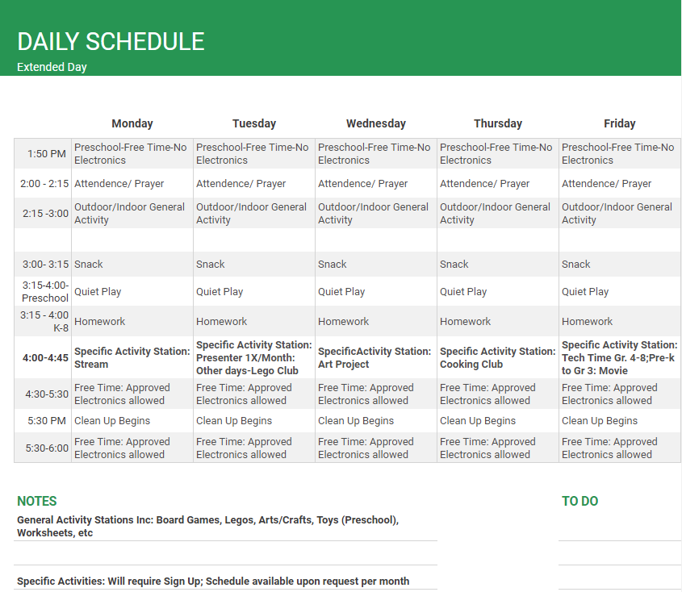

Tentative Monthly Specials

September
National Guide Dog Awareness : Methuen Police
October
National Bully Prevention -In house Stream activity
November
National Literacy month-Nevins Library
December
Christmas -In house Stream activity
January
Mental wellness month : Yoga class
February
Oral Hygiene month -Dental Hygienist/Dentist
March
National Nutrition month -In house healthy snacking (cooking) activity
April
Prevention of Cruelty to Animals -MSPCA
May
National Correct Posture month-Dr. Berard: Why do we have to sit that way?
June
National Safety Month-Methuen Police

- These are examples—they will finalized within the next few weeks.

Weekly Specialty: Sample Schedule
**Schedule is subject to change based on enrollment and staffing.

Lego
Will Noah's boat float?

Idea: Teams, sectioned by age groups, will be building a boat from legos. They will put their boat in metal bowl, ¾ filled with water. One by one, you add pennies to the boat to see if it sinks/floats. You observe and record: How many pennies did it take to sink it and how long before it actually fully sunk. To incorporate Religion,this is called will Noah's boat float. Discussion around the name of the activity will occur.

Skills: Teamwork /Communication (Building), Science (Recording and Observing)

Art
Garden of Learners

Idea: No matter if you are big or small, our garden of learners is fun for all!
Students will use washable paint to make “flowers” from their hands. We will attach a stem with their name and grade on it. It will also have one thing about them on the stem. This will be our Welcome Board.

Skills: Fine Motor Skills( cutting/pasting/painting) and Creativity (one thing about you)

Cooking
DIY Ice Cream Sundae

Idea: Students will prepare their own ice cream using the bag system. Dairy free for all, including those lactose intolerant.

Skills: Math (measuring) and Creativity (making sundaes from the ice cream)

Tech Time (Gr. 4-8)/Movie Time (pre K-3)
Idea: Where in the Bible Scavenger Hunt

Skills: Religion (becoming familiar with different parts of the bible), Tech (using the computers)

